***Software Design Specification***

for

*Q-Taskers*

*Prepared by :*

*<Karan Inder Singh(U101116FCS057)*

*Rishabh Gaur(U101116FCS100)*

*Rahul Saha(U101116FCS241)*

*Rajat Srivastav(U101116FCS098)*

# > <Software Engineering CS-301>

**Software Design Specification**

Table of Contents

1. **Introduction** 
   1. Purpose of this document
   2. Scope of the development project
   3. Definitions, acronyms, and abbreviations
   4. Overview of document

1. **Conceptual Architecture/Architecture Diagram** 
   1. Structure and relationships
   2. User interface issues

1. **Logical Architecture (Class Diagram, Sequence Diagram, State Diagram)** 
   1. Logical Architecture Description
   2. Class name: Login
   3. Class Name: Service Provider page
   4. Class Name: Admin page
   5. Class Name: Service Provider edit profile
   6. Class Name: User edit profile
   7. Class Name: Admin edit profile
   8. Class Name: User page
   9. Class Name: Service Provider view profile
   10. Class Name: User view profile
   11. Class Name: Admin view profile
   12. Class Name: View orders
   13. Class Name: place order
   14. Class Name: View Service
   15. Class name: view analysis

* 1. **Execution Architecture**
  2. Reuse and relationships to other products

**5.0 Design decisions and tradeoffs**

**6.0 Pseudocode for components**

**7.0 Coding Metrics**

**8.0 Minutes of Meeting with Service Provider**

## SOFTWARE DESIGN SPECIFICATION

**The Software Design Specification Outline**

### 1. Introduction

The Software Design Document is a document to provide documentation which will be used to aid in software development by providing the details for how the software should be built. Within the Software Design Document are narrative and graphical documentation of the software design for the project including use case models, sequence diagrams, state diagram, class diagram and other supporting requirement information.

**1.1 Purpose of this document**

This document will define the design of the Business Application. It contains specific information about the expected input, output, classes, and functions. The interaction between the classes to meet the desired requirements are outlined in detailed figures at the end of the document.

**1.2 Scope of the development project**

We describe what features are in the scope of the software and what are not in the scope of the software to be developed.

In Scope:

1. Application for the Business which have proper Hierarchy
2. Service Provider can retrieve the information about the User.

c. Ease in Maintaining a Record. Out of Scope:

1. Errors Due to Location Services (Google Maps API)

* 1. **Definitions, acronyms, and abbreviations IEEE: Institute of Electrical and**

**Electronics Engineers**

IEEE: Institute of Electrical and Electronics Engineers

SDS: Software Design Specification

* 1. **Overview of document**

This SDS is divided into 5 sections with various sub-sections. The sections of the Software Design Document are:

1.​ **Introduction:**​ describes about the document, purpose, scope of development project definitions and abbreviations used in the document.

1. ​**Logical Architecture**​: describes Logical Architecture Description and Components.

1. ​**Execution Architecture:**​ defines the runtime environment, processes, deployment view.

1. ​**Design Decisions and Trade-offs:** ​describes the decisions taken along with the reason as to why they were chosen over other alternatives.

1. ​**Appendices:**​ describes subsidiary matter if any.

#### 2.1 Logical Architecture Description

**2.1.1 Class Diagram explanation:**

Most of the classes extends AppCompatActivity class which is being shown by association linkage. It is being shown by black-coloured diamond. The classes which extends AppCompatActivity are: UserAbout, AdminAbout, ServiceDataAdapter, SerivceListings, FAQ_Admin, UserLanding, Login, Notification, UserFAQ, Home, ViewAdminProfile, AboutService, ServiceData, AdminAbout, UserAbout, ViewProfile_User, UserAccount.

**3. Logical Architecture (Class Diagram, Sequence Diagram, State Diagram)**

**Class Diagram:**

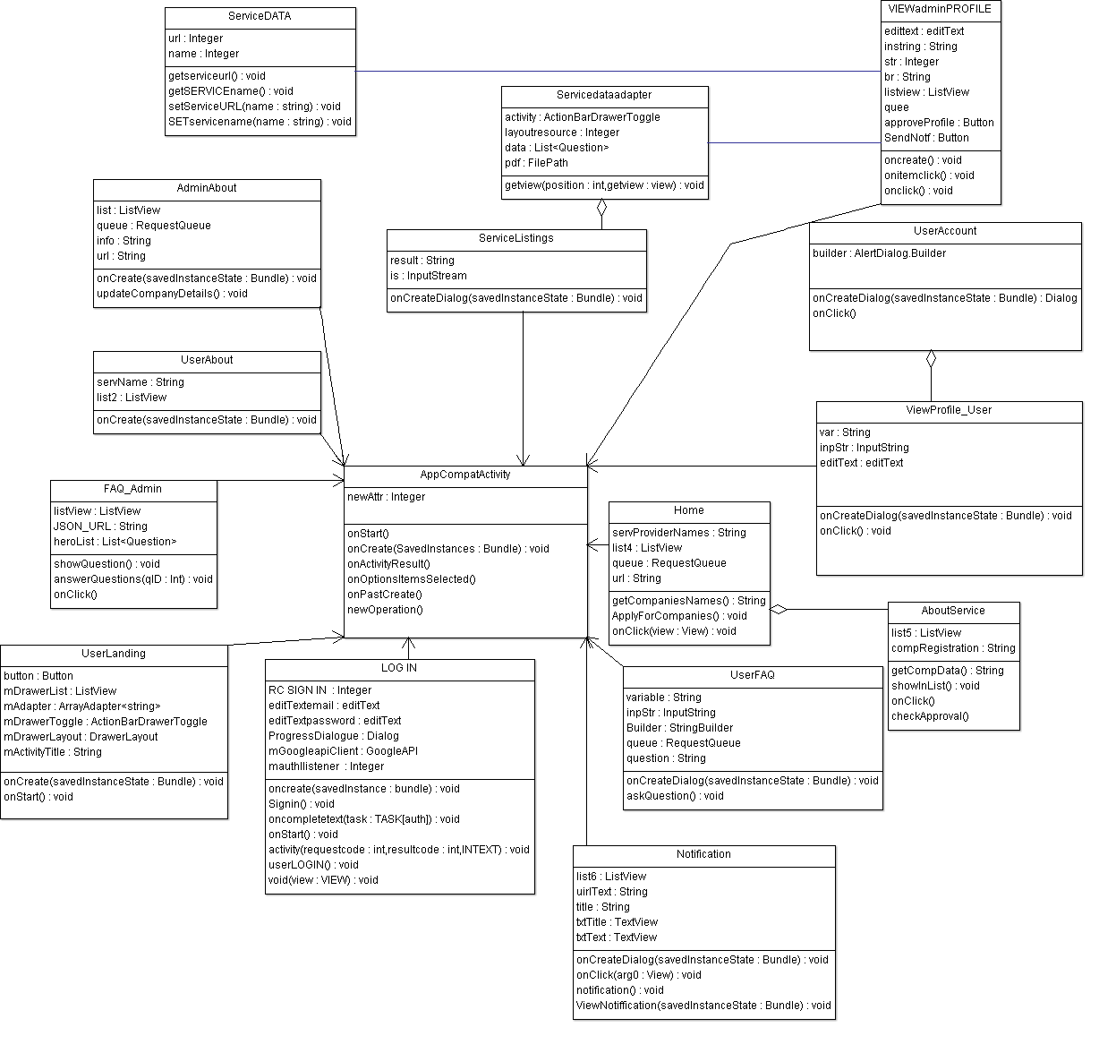

**Sequence Diagram:**

**(Service Provider, User, Admin)**

**SignUp**

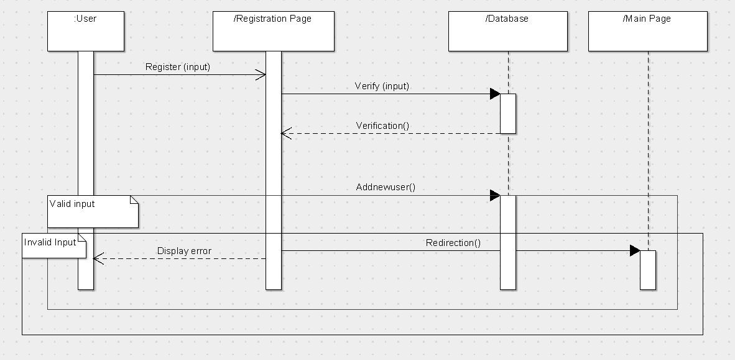

### User:-

### User Login

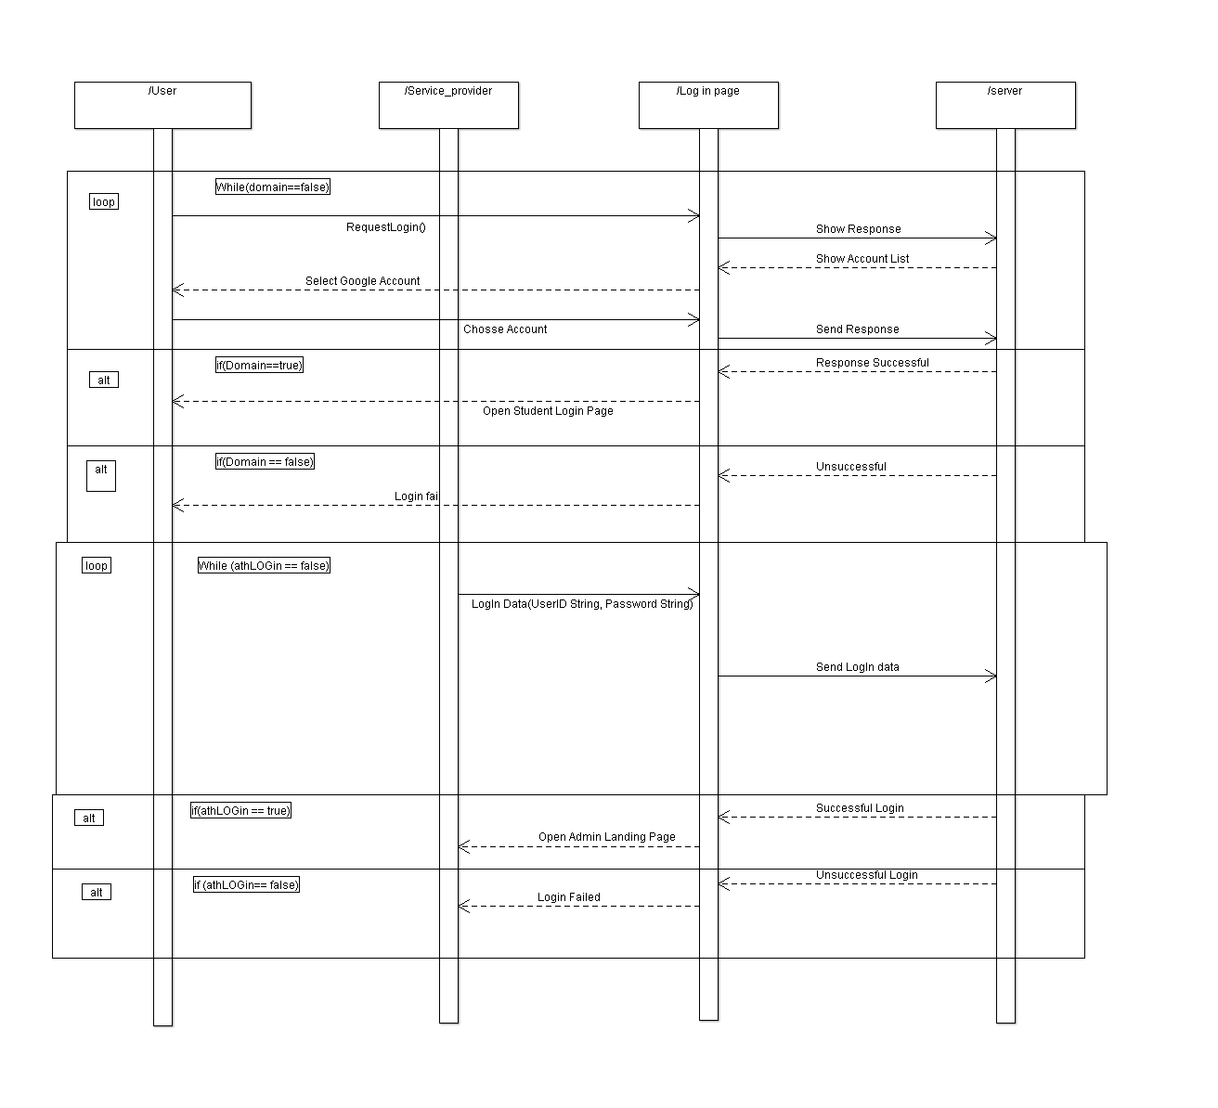

**User Display Profile Details &**

**Update Details**

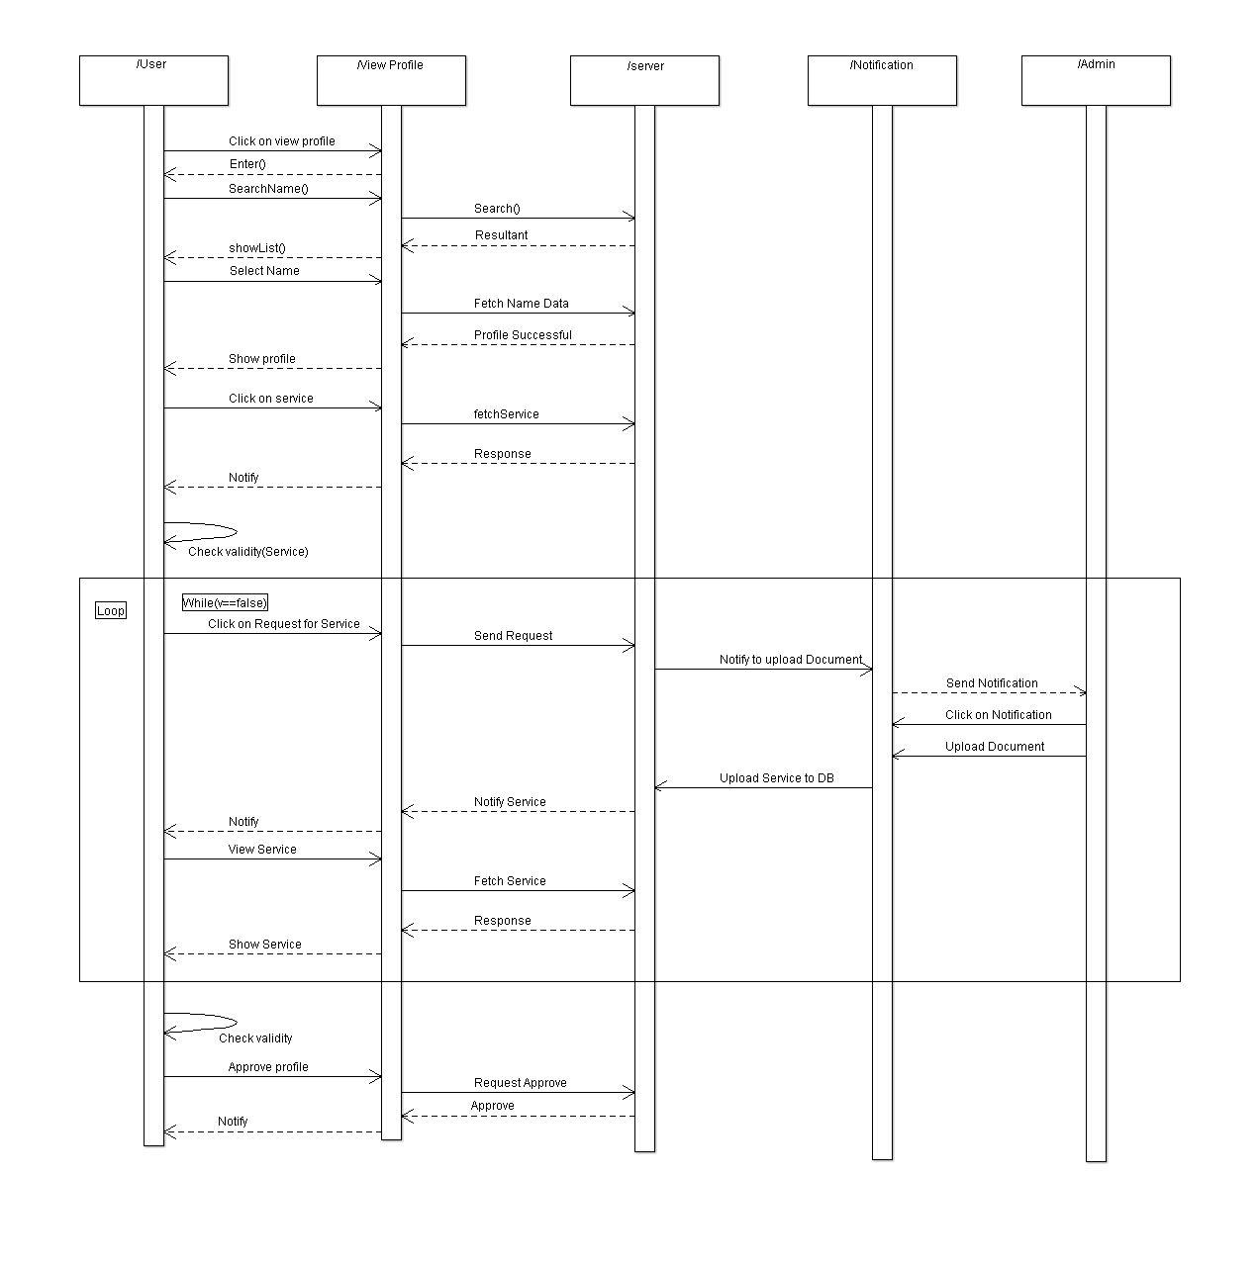

**User Place Order**

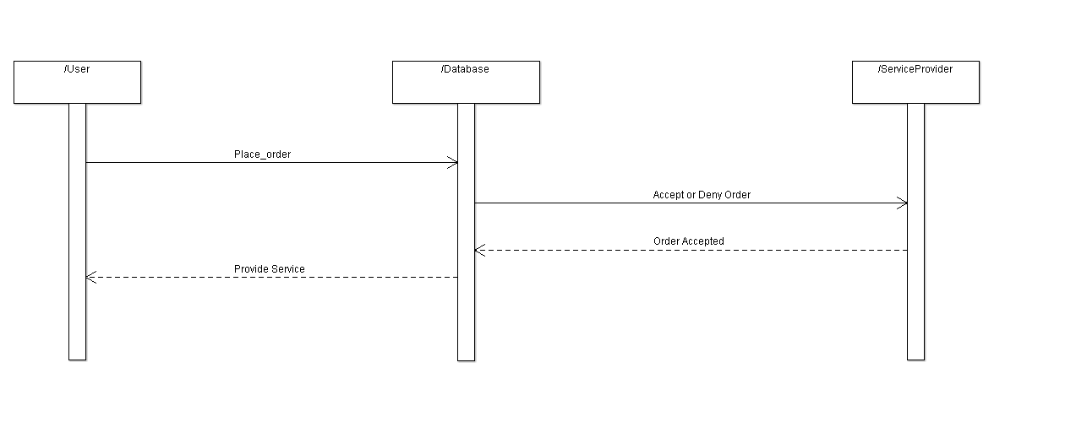

**User View Order**

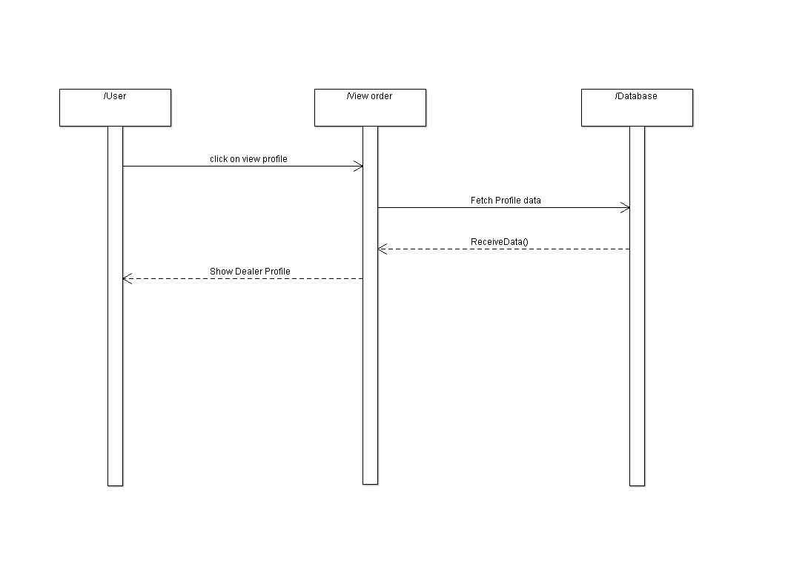

**Service Provider:-**

**Service Provider Display Profile Details &**

**Update Details**

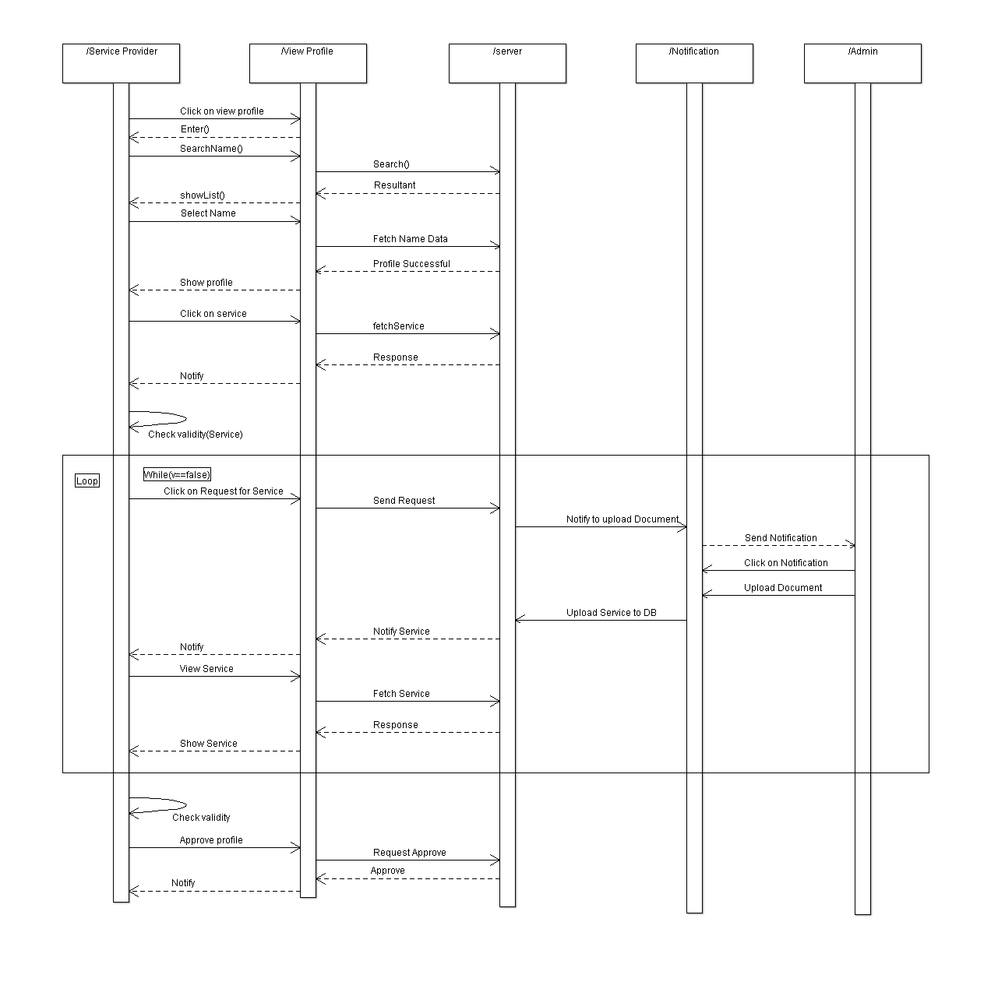

**Service Provider Login**

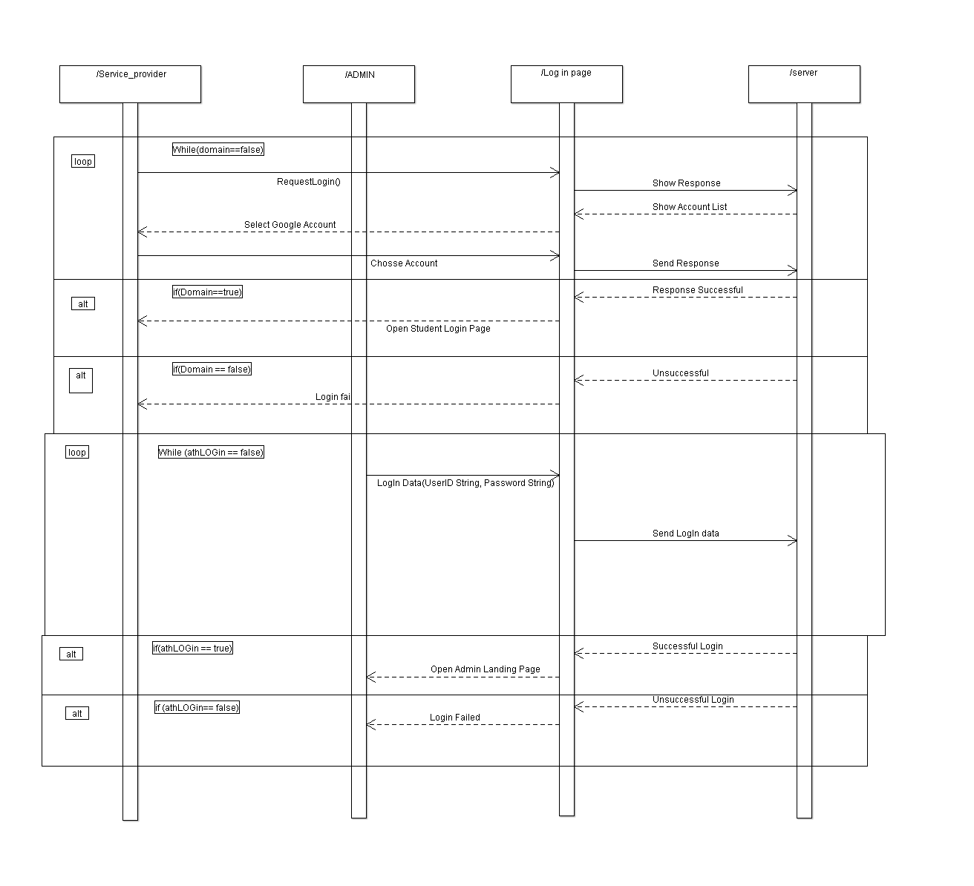

**Service Provider View Analytics**

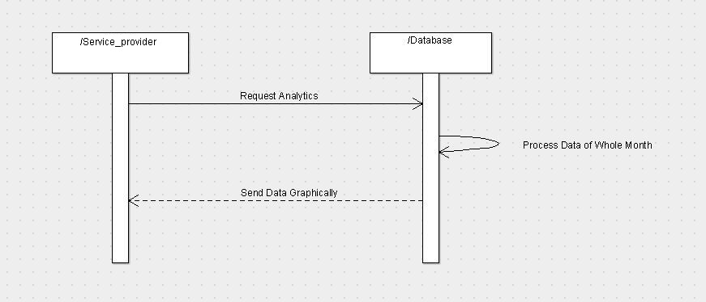

**Service Provider View Order**

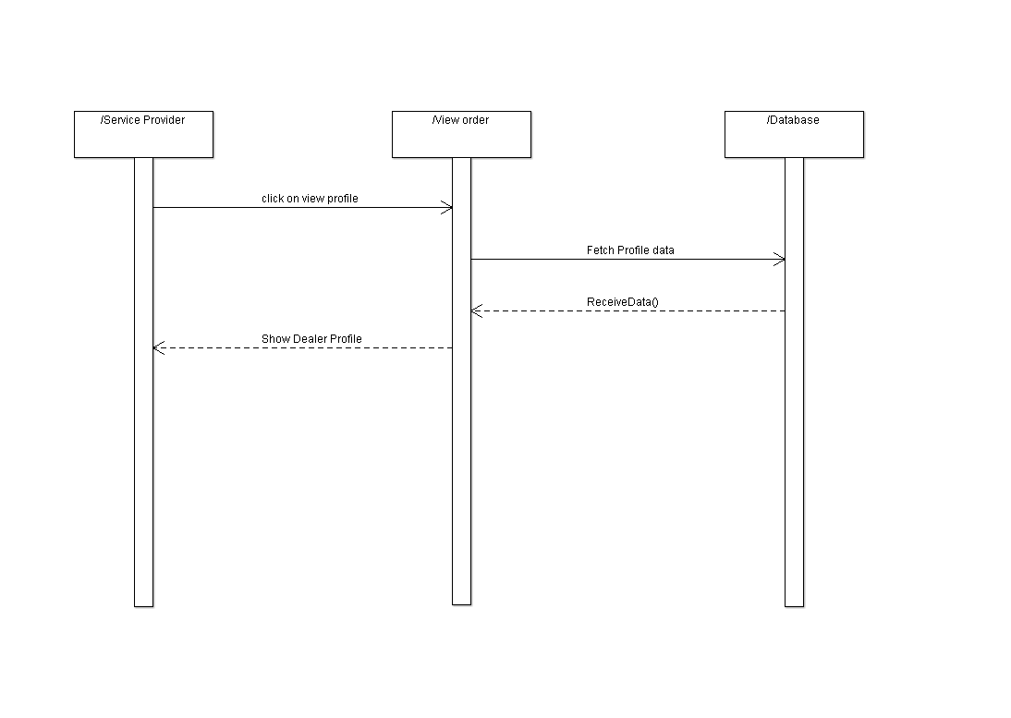

**Admin:-**

**Admin Login**

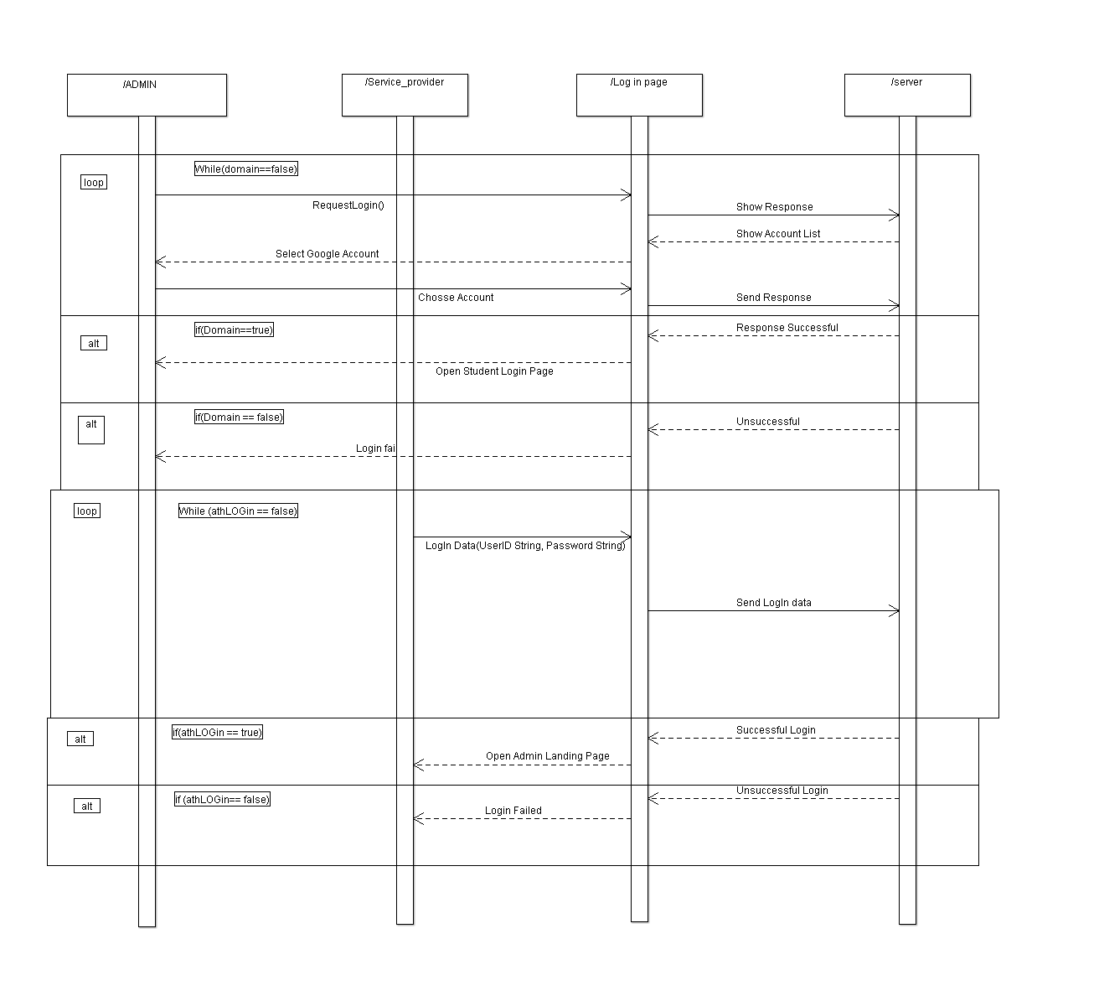

**Admin Display Profile Details &**

**Update Details**

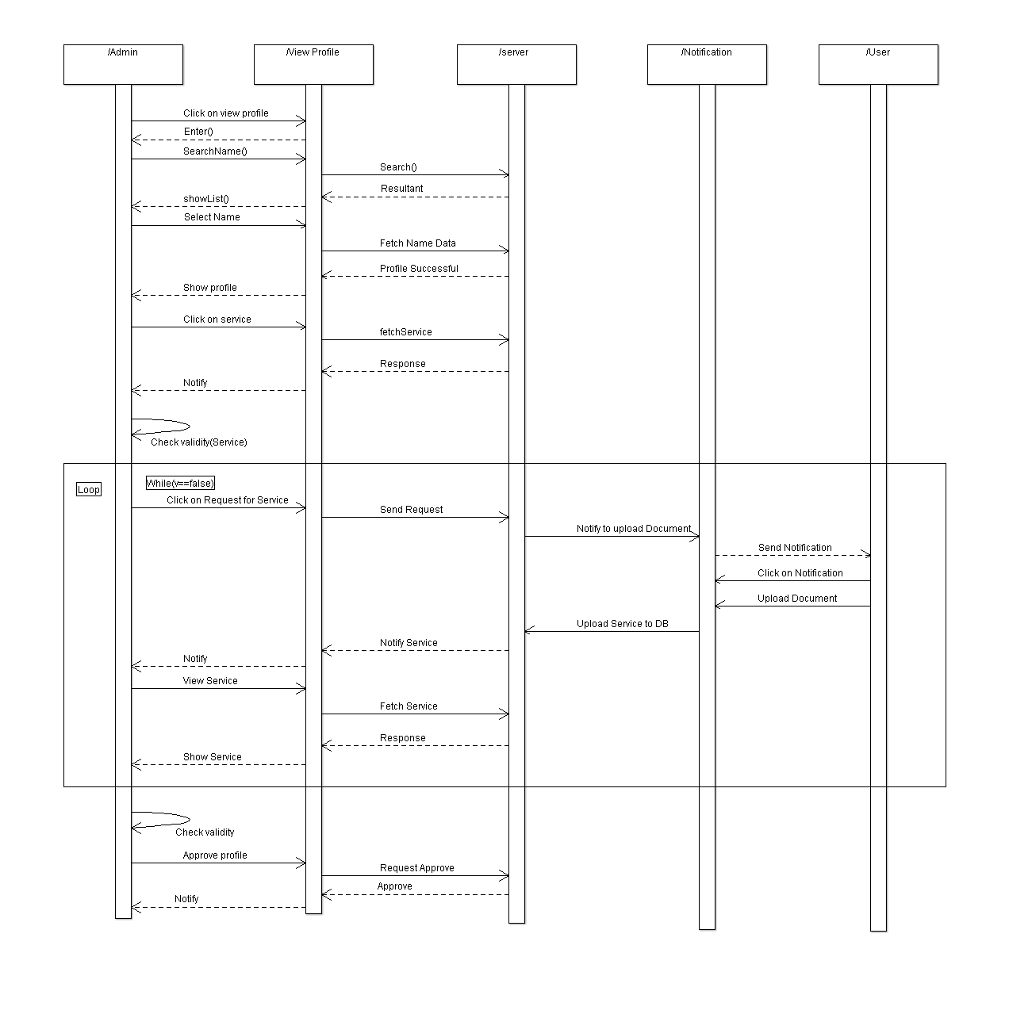

**Admin View Order**

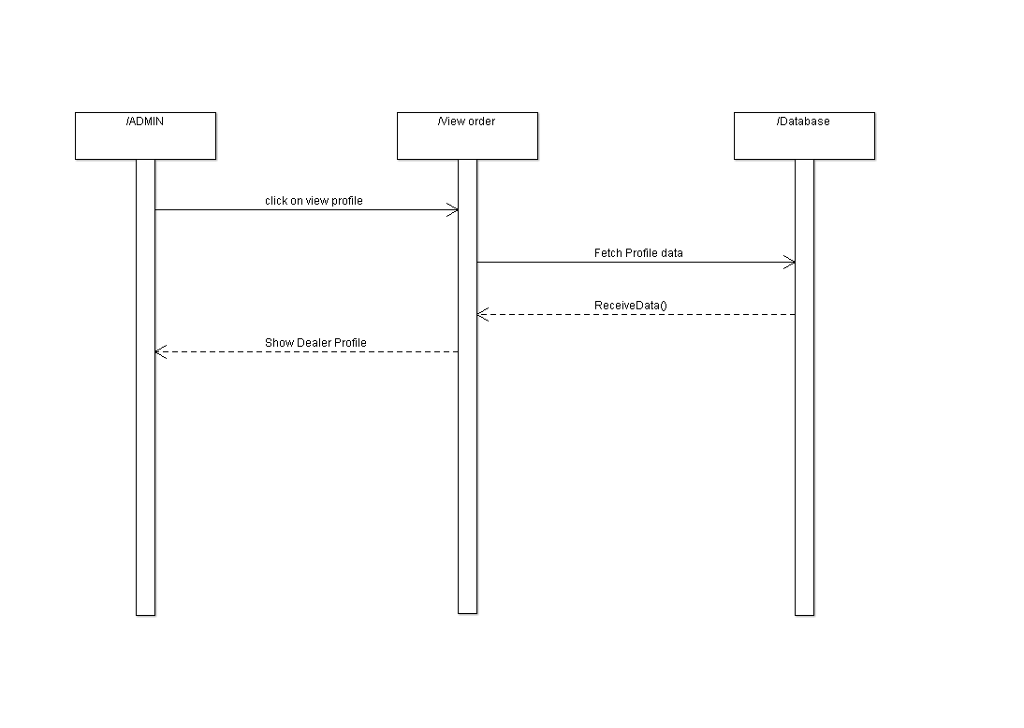

**Admin View Analytics**

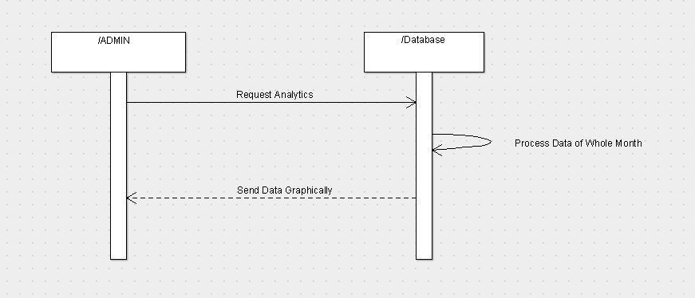

**Service List:**

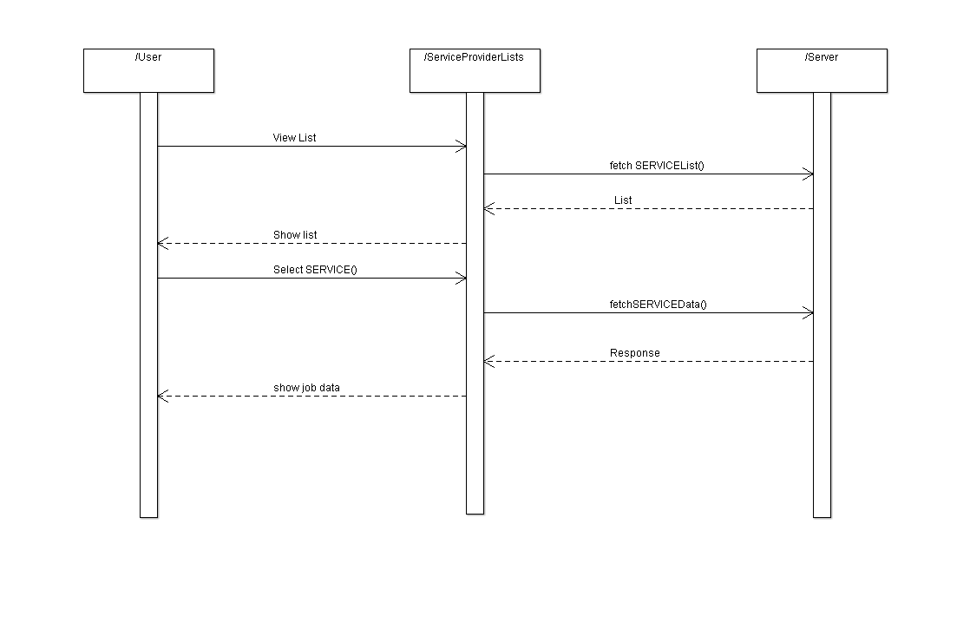

**FAQ:**

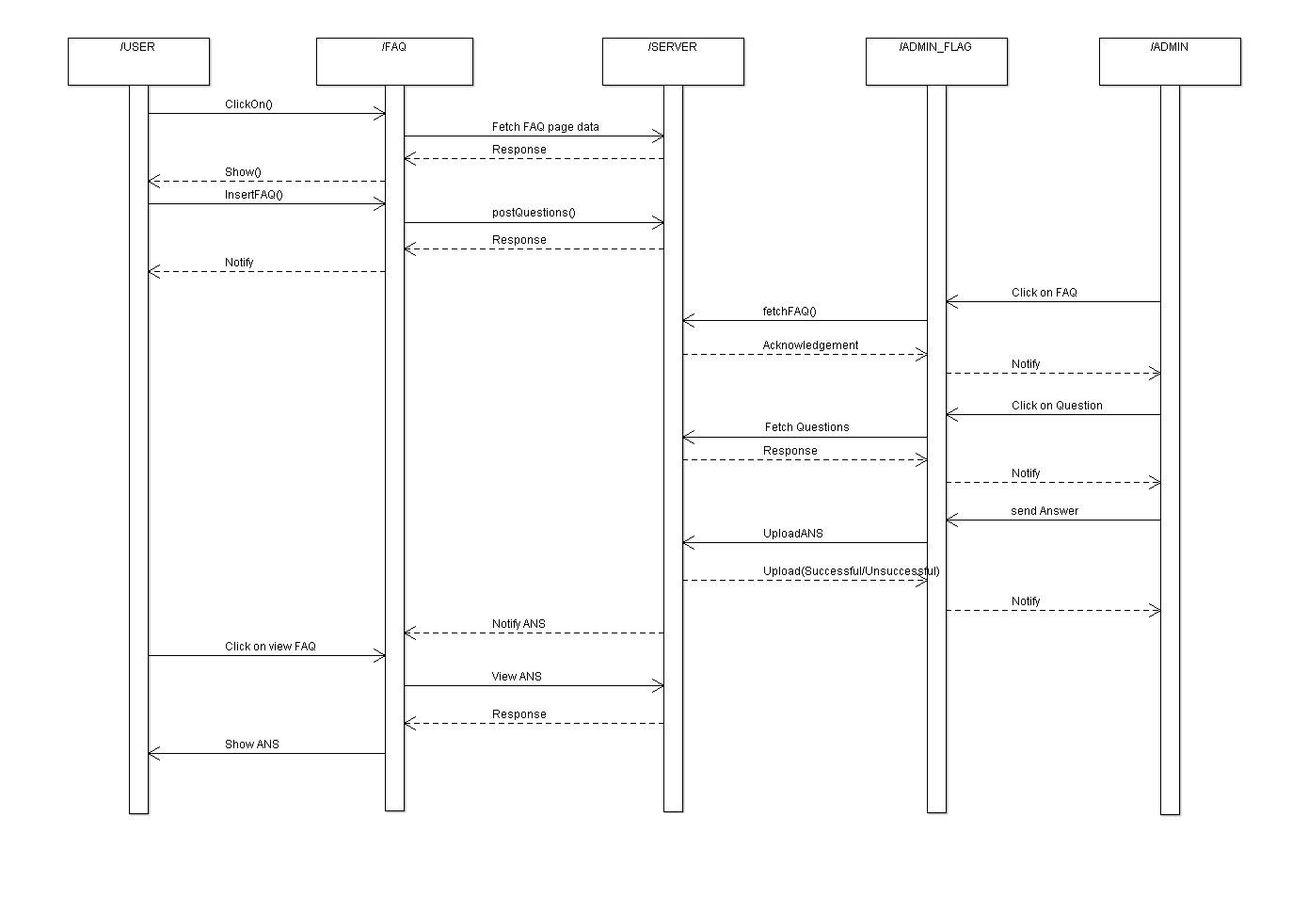

**About:**

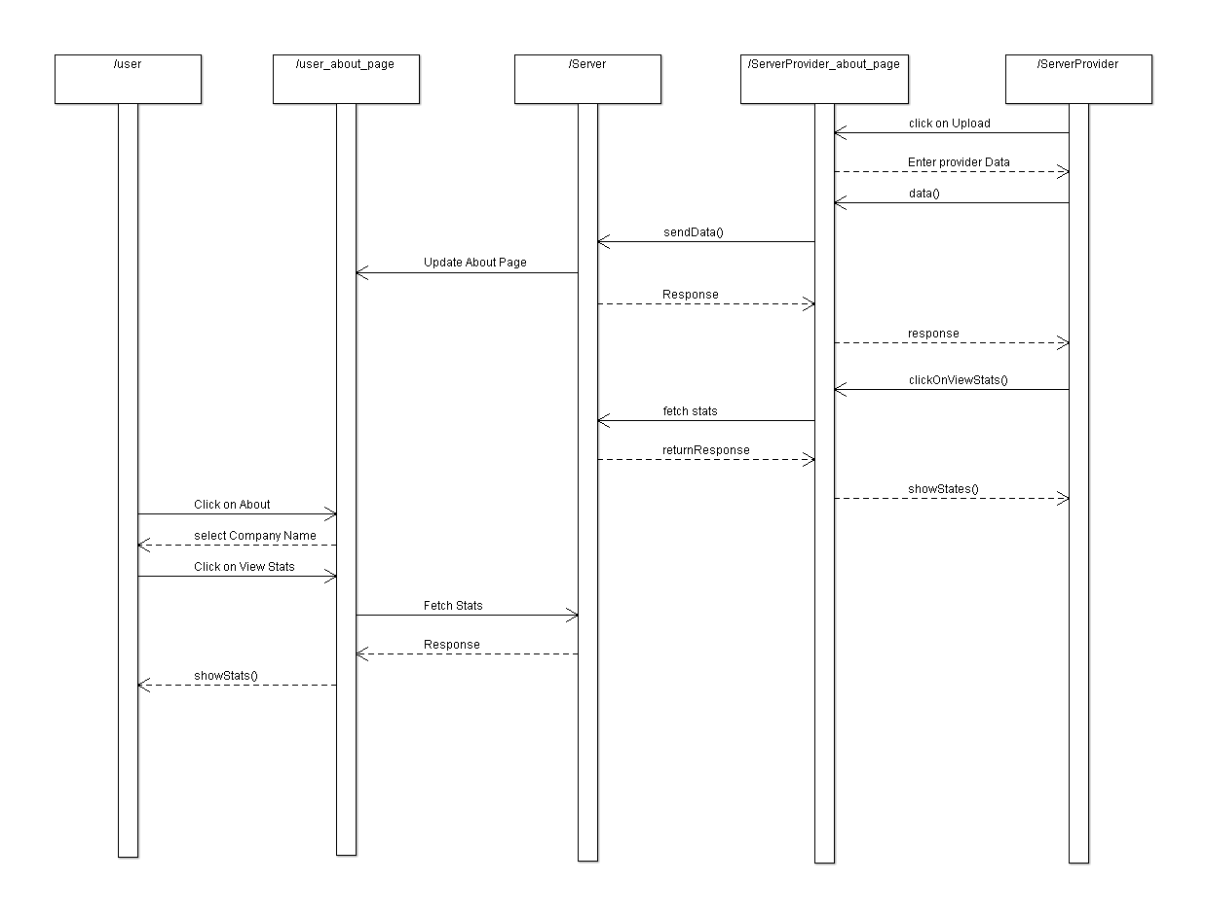

**State Diagram:**

**Admin About:**

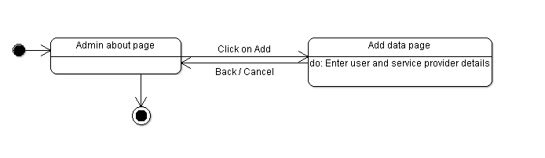

**Admin Login Page:**

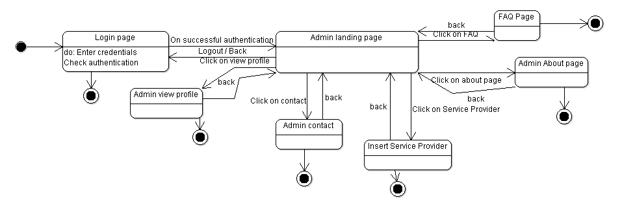

**Admin FAQ:**

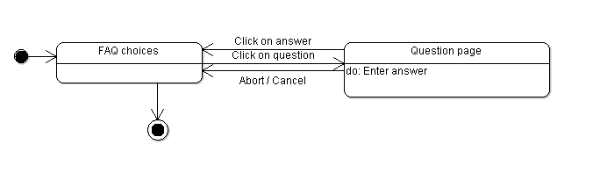

**Service Provider About:**

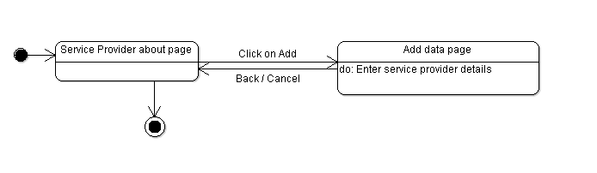

**Service Provider Account Page:**

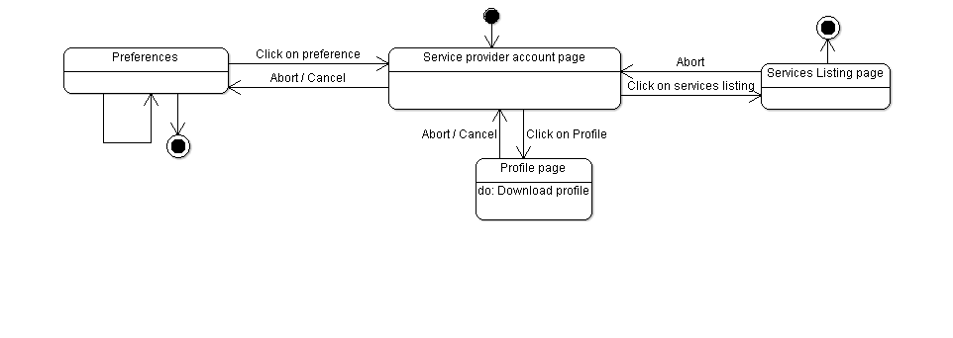

**Service Provider** **View Service:**

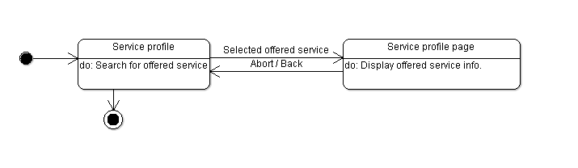

**Service Provider FAQ:**



**Service Provider Login Page:**

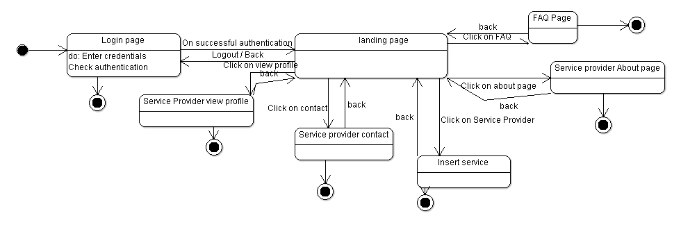

**Service Provider**

**Service Order Accepted:**

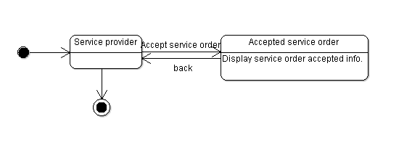

**User About:**

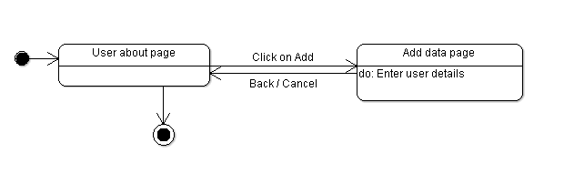

**User View Service:**

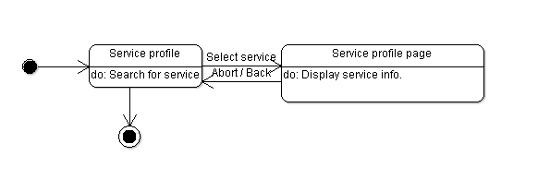

**User Account Page:**

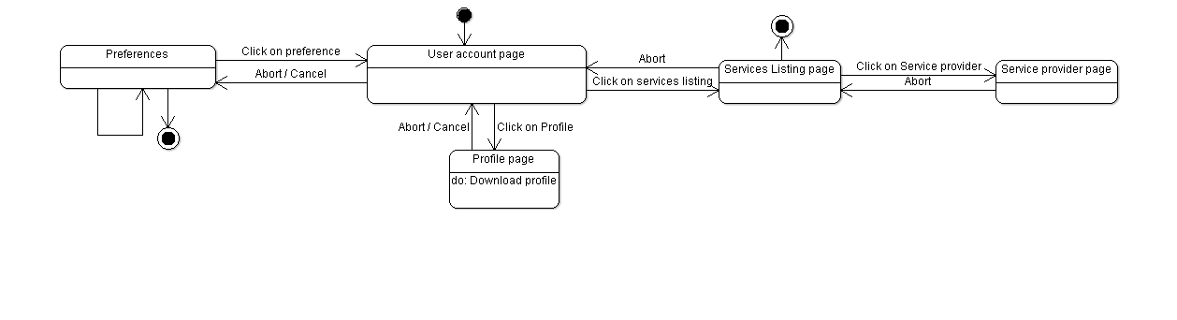

**User FAQ:**



**User Login Page:**

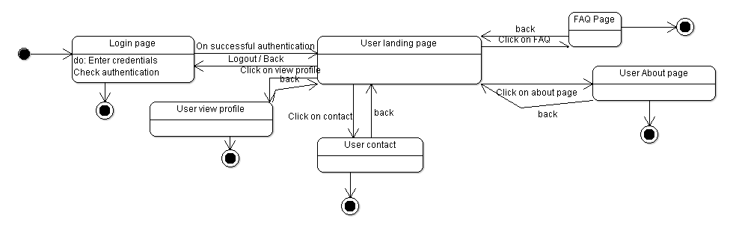

**User Service Order:**

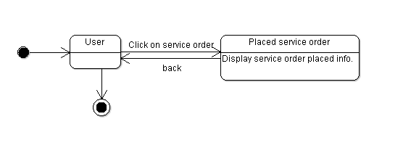

**3.1.2 Sequence Diagram:**

Arrow line signifies there is a send message taken place. Response is being shown by dotted arrows.

**3.1.2.1 LogIn:**

It allows user to login with mail ,domain and Admin to login with the username and password that are being registered in the database already. It’s loops being on same page until the correct information is not given.

**3.1.2.2 Sign-up:**

the user is not logged in , the user can log in as Service Provider, User or Admin.

**3.1.2.3 View Profile :**

It allows user to view his profile which includes his details.

**3.1.2.4 Edit Profile :**

It allows user to edit his profile information.

**3.1.2.5: Place Orders :**

It allows user to place orders.

**3.1.2.6: View Orders:**

It allows user to view orders placed.

**3.1.2.7 : Analytics :**

It allows Service Provider to analyze the sale of Service graphically.

#### 3.1.3 State Diagram

Initial state is being shown by starting with a black dot. Final State is being shown by the black dot surrounded by an empty circle.

**3.1.3.1 Service Provider LoginIn Page:**

On the Login page Service Provider will enter his or her details that will include phone number and password , after entering the login details when the user will click on login button and then user will be transferred on his dashboard page.

**3.1.3.2 User LoginIn Page:**

On the Login page User will enter his or her details that will include phone number and password , after entering the login details when the user will click on login button and then user will be transferred on his dashboard page.

**3.1.3.3 Admin LoginIn Page:**

​On the Login page Admin will enter his or her details that will include phone number and password , after entering the login details when the user will click on login button and then user will be transferred on his dashboard page.

**3.1.3.4 SignUp :**

If the user is not logged in , he or she will click on the signUp button which will transfer the user to a to page where the user is supposed to fill all the necessary details i.e name, address , phone number and password, after filling the required information to sign up , the user will click on the signup button which will register the user as Service Provider, User or Admin into the database.

**3.1.3.5 Service Provider ViewProfile:**

On clicking the ViewProfile button the Service Provider can view his or her details which will include all the necessary details i.e name, address and phone number.

**3.1.3.6 User ViewProfile:**

On clicking the ViewProfile button the User can view his or her details which will include all the necessary details i.e name, address and phone number.

**3.1.3.7 Admin ViewProfile:**

On clicking the ViewProfile button the Admin can view his or her details which will include all the necessary details i.e name, address and phone number.

**3.1.3.8 Service Provider EditProfile:**

On clicking the EditProfile button the Service Provider can edit his or her details.

**3.1.3.9 User EditProfile:**

On clicking the EditProfile button the User can edit his or her details.

**3.1.3.10 Admin EditProfile:**

On clicking the EditProfile button the Admin can edit his or her details.

**3.1.3.11 PlaceOrders(Service Provider) :**

On clicking the PlaceOrders button the Service Provider can view all the orders placed.

**3.1.3.12 PlaceOrders(User) :**

On clicking the PlaceOrders button the User can view all the orders placed.

**3.1.3.13 ViewService(Service Provider):**

On clicking the ViewService button the Service Provider can view Services.

**3.1.3.14 ViewService(User):**

On clicking the ViewService button the User can view Services.

**3.1.3.15 Services:**

On clicking the ​Service button the Service Provider can see Services.​

**3.1.3.19 Analytics :**

On clicking the analytics button the ​user can view and analyse the sales of Service geographically.

#### 3.2 Class Name: Login

**Description :**

The Class allows the user to enter the System by authenticating the entered credentials.

**3.2.1 Method 1:checkCrediantials()**

**Method Description:**

When the User Enters the Credentials this method will be called. Inside this method it will check weather the username and password entered is there in the database and

correct.Since it is a login activity so several state may occur like

* When user is signed out
* After Login is successful

**3.2.2 Method 2:Sign Up()**

**Method Description:**

When the User clicks the ‘not a user’ link then this method is invoked and takes the user to the Sign Up Page.

**3.3 Class Name:Sign Up**

**Description :** ​The Class allows the user to enter the Credentials in the System and Sign Up for the Application and store the user information.

**3.3.1 Method 1:register_User()**

**Method Description:**

This method stores the user information in the firebase and is invoked when Sign Up button is clicked.

#### 3.4 Class Name: Service Provider Page

**Description :** ​This Class Opens the Main Service Provider Page And Enables the User the to use various options like place Orders, View Orders, View Analytics, etc

**3.4.1 Method 1:ViewOrders()**

​**Input:**​ Click View Orders Button

​**Output:**​ Open View Orders Page

**Method Description:**

This Method Lets the Main Service Provider to View the Orders placed by the Sub Service Provider, See the Sub Service Providers name and the Details of the orders placed by the Sub Service Provider.

**3.4.2 Method 2: View Service()**

​**Input:**​ Click View Service Button

​**Output:**​ Open Service Page

**Method Description:**

This Method Lets the Main Service Provider to View the total Service which is left that is the total Service which is available with the Service Provider to distribute to the Service Provider.

**3.4.4 Method 4:View Analytics()**

​**Input:**​ Click View Analytics Button

​**Output:**​ Open Analytics Layout

**Method Description:**

This Method is invoked when the Analytics Button is Placed. This Method will Process the Data and Show the Total Sales of the Service Graphically.

**3.4.5 Method 5:View Profile()**

**Method Description:**

This Option is Available on the View Profile Page and lets the Service Provider see his Credentials entered during the time of Sign Up.

**3.4.6 Method 5:Edit Profile()**

**Method Description:**

This Option is Available on the View Profile Page and lets the Service Provider to Edit His/Her Profile accordingly and let the User Save the Edited Credentials.

#### 3.5 Class Name: Admin Page

**Description :** ​This Class Opens the Admin Page And Enables the User the to use various options like place Orders, View Orders, View Analytics, etc

**3.5.1 Method 1:ViewOrders()**

​**Input:**​ Click View Service Button

​**Output:**​ Open View Orders Page

**Method Description:**

This Method lets the Admin to View the Orders placed by him and the Details of the orders.

**3.5.2 Method 2:View Profile()**

**Method Description:**

This Option is Available on the View Profile Page and lets the Admin see his Credentials entered during the time of Sign Up.

**3.5.3 Method 3:Edit Profile()**

**Method Description:**

This Option is Available on the View Profile Page and lets the Admin to Edit His/Her Profile accordingly and let the User Save the Edited Credentials.

**3.5.4 Method 4:EnterLocation()**

​**Input:**​ Click Enter Location Button

​**Output:**​Save Admin Information

**Method Description:**

This Method Will Store the Location of the Admin in the Database and Be Used for the Future to View The Admin’s Location.

**3.5.5 Method 5: place Order() :**

**Input :** ​Click place order button

**Output :** ​Open place order page

**Method Description :**

This method when invoked will allow the Admin to place an order.

#### 3.6 Class Name: Service Provider Edit Profile

**Description :** ​This class opens the Edit profile page and enables the Service Provider to edit his profile information which includes his name, address, password and etc.

**3.6.1 Method 1: editName() Input:** ​Click Edit Profile Button.

**Output :** ​Open Edit Profile Page.

**Method Description:**

​This method lets the Service Provider to edits his name.

**3.6.2**​ ​**Method 2**​: ​**editPhoneNo() Input:** ​Click Edit Profile Button.

**Output :** ​Open Edit Profile Page.

**Method Description:**

This method lets the Service Provider to edits his phone number.​

**3.6.3**​ ​**Method 2**​: ​**editGender() Input:** ​Click Edit Profile Button.

**Output :** ​Open Edit Profile Page.

**Method Description:**

​This method lets the Service Provider to edits his/her gender.

**3.6.4 Method 2**​: ​**editAddress() Input:** ​Click Edit Profile Button.

**Output :** ​Open Edit Profile Page.

**Method Description:**

​This method lets the Service Provider to updates his address.

**3.6.5 Method 2**​: ​**editPassword() Input:** ​Click Edit Profile Button.

**Output :** ​Open Edit Profile Page.

**Method Description:**

​This method lets the Service Provider to edit his password.

#### 3.7 Class Name:User Edit Profile

**Description :** ​This class opens the Edit profile page and enables the User to edit his profile information which includes his name,address,password and etc.

**3.7.1 Method 1: editName() Input:** ​Click Edit Profile Button.

**Output :** ​Open Edit Profile Page.

**Method Description:**

​This method lets the User to edits his name.

**3.7.2**​ ​**Method 2**​: ​**editPhoneNo() Input:** ​Click Edit Profile Button.

**Output :** ​Open Edit Profile Page.

**Method Description:**

​This method lets the User to edits his phone number.

**3.7.3**​ ​**Method 2**​: ​**editGender() Input:** ​Click Edit Profile Button.

**Output :** ​Open Edit Profile Page.

**Method Description:**

​This method lets the User to edits his/her gender.

**3.7.4 Method 2**​: ​**editAddress() Input:** ​Click Edit Profile Button.

**Output :** ​Open Edit Profile Page.

**Method Description:**

​This method lets the User to updates his address.

**3.7.5 Method 2**​: ​**editPassword() Input:** ​Click Edit Profile Button.

**Output :** ​Open Edit Profile Page.

**Method Description:**

​This method lets the User to edit his password.

#### 3.8 Class Name:Admin Edit Profile

**Description :** ​This class opens the Edit profile page and enables the Admin to edit his profile information which includes his name,address,password and etc.

**3.8.1 Method 1: editName() Input:** ​Click Edit Profile Button.

**Output :** ​Open Edit Profile Page.

**Method Description:**

​This method lets the Admin to edits his name.

**3.8.2**​ ​**Method 2**​: ​**editPhoneNo() Input:** ​Click Edit Profile Button.

**Output :** ​Open Edit Profile Page.

**Method Description:**

This method lets the Admin to edits his phone number.​

**3.8.3**​ ​**Method 2**​: ​**editGender() Input:** ​Click Edit Profile Button.

**Output :** ​Open Edit Profile Page.

**Method Description:**

​This method lets the Admin to edits his/her gender.

**3.8.4 Method 2**​: ​**editAddress() Input:** Click Edit Profile Button.​

**Output :** ​Open Edit Profile Page.

**Method Description:**

​This method lets the Admin to updates his address.

**3.8.5 Method 2**​: ​**editPassword() Input:** ​Click Edit Profile Button.

**Output :** ​Open Edit Profile Page.

**Method Description:**

​This method lets the Admin to edit his password.

#### 3.9 Class Name: Sub Service Provider Page

**Description :** ​This Class Opens the Sub Service Provider Page And Enables the User the to use various options like place Orders, View Orders of the Admin, View Profile,Edit Profile , etc

**3.9.1 Method 1:ViewOrders()**

​**Input:**​ Click View Orders Button

​**Output:**​ Open View Orders Page

**Method Description:**

This Method Lets the Sub Service Provider to View the Orders placed by the Admin, See the Admin’s name and the Details of the orders placed by the Admin.

**3.9.2 Method 2:View Service()**

​**Input:**​ Click View Service Button

**Output:**​ ​ Open Service Page  **Method Description:**

This Method Lets the Sub Service Provider to View the total Service which is left that is the total Service which is available with the SubService Provider and when to place an order to the Service Provider.

**3.9.3 Method 5:Edit Profile()**

**Method Description:**

This Option is Available on the View Profile Page and lets the Sub Service Provider to Edit His/Her Profile accordingly and let the User Save the Edited Credentials.

**3.9.4 Method 5:View Profile()**

**Method Description:**

This Option is Available on the View Profile Page and lets the Sub Service Provider see his Credentials entered during the time of Sign Up.

#### 3.10 Class Name:Service Provider View Profile

**Description :**

​This class opens the View profile page and enables the Service Provider to view his profile information which includes his name,address,password and etc.

**3.10.1 Method 1: viewName()**

**Input:** ​Click View Profile Button.

**Output :** Open View Profile Page.​

**Method Description:**

​This method lets the Service Provider to view his name.

**3.10.2**​ **Method 2**​ ​: ​**viewPhoneNo() Input:** ​Click View Profile Button.

**Output :** Open View Profile Page.​

**Method Description:**

​This method lets the Service Provider to view his phone number.

**3.10.3**​ ​**Method 2**​: ​**editGender() Input:** ​Click View Profile Button.

**Output :** ​Open View Profile Page.

**Method Description:**

This method lets the Service Provider to view his/her gender.​

**3.10.4 Method 2**​: ​**ViewAddress() Input:** ​Click View Profile Button.

**Output :** ​Open View Profile Page.

**Method Description:**

​This method lets the Service Provider to view his address.

**3.10.5 Method 2**:​ **viewPassword()**​  **Input:** ​Click view Profile Button.

**Output :** ​Open View Profile Page.

**Method Description:**

​This method lets the Service Provider to view his password.

#### 3.11 Class Name:User View Profile

**Description :** ​This class opens the View profile page and enables the SubService Provider to view his profile information which includes his name,address,password and etc.

**3.10.1 Method 1: viewName()**

**Input:** ​Click View Profile Button.

**Output :** ​Open View Profile Page.

**Method Description:**

​This method lets the SubService Provider to view his name.

**3.10.2**​ ​**Method 2**​: ​**viewPhoneNo() Input:** Click View Profile Button.​

**Output :** ​Open View Profile Page.

**Method Description:**

​This method lets the SubService Provider to view his phone number.

**3.10.3**​ ​**Method 2**​: ​**editGender() Input:** Click View Profile Button.​

**Output :** ​Open View Profile Page.

**Method Description:**

​This method lets the SubService Provider to view his/her gender.

**3.10.4 Method 2**​: ​**ViewAddress() Input:** Click View Profile Button.​

**Output :** ​Open View Profile Page.

**Method Description:**

​This method lets the SubService Provider to view his address.

**3.10.5 Method 2**​:​**viewPassword() Input:** ​Click view Profile Button.

**Output :** ​Open View Profile Page.

**Method Description:**

​This method lets the SubService Provider to view his password.

#### 3.12 Class Name:Admin View Profile

**Description :**

​This class opens the View profile page and enables the Admin to view his profile information which includes his name,address,password and etc.

**3.10.1 Method 1: viewName()**

**Input:** ​Click View Profile Button.

**Output :** ​Open View Profile Page.

**Method Description:**

​This method lets the Admin to view his name.

**3.10.2**​ ​**Method 2**​: ​**viewPhoneNo() Input:** ​Click View Profile Button.

**Output :** Open View Profile Page.​

**Method Description:**

​This method lets the Admin to view his phone number.

**3.10.3**​ ​**Method 2**​: ​**editGender() Input:** ​Click View Profile Button.

**Output :** ​Open View Profile Page.

**Method Description:**

​This method lets the Admin to view his/her gender.

**3.10.4 Method 2**​: ​**ViewAddress() Input:** ​Click View Profile Button.

**Output :** ​Open View Profile Page.

**Method Description:**

​This method lets the Admin to view his address.

**3.10.5 Method 2**​:​**viewPassword() Input:** ​Click view Profile Button.

**Output :** ​Open View Profile Page.

**Method Description:**

​This method lets the Admin to view his password.

#### 3.13 Class Name:View Orders

**Description:**

This Class will allow the Service Provider, Sub Service Provider and The Admin to view his/her Orders and the Quantity of Service Places .

**3.13.1 Method 1:show_order_list()**

​**Input:**​ User Clicks View Order Button **Output:**​ Open A List of Orders

**Method Description**

This Method when invoked will allow the Service Provider, Sub Service Provider and The Admin to view his/her Orders and the Quantity in the Form of List and will show the details of the item /Order Placed

#### 3.14 Class Name: Place Orders

**Description:**

This class opens the Place order page and enables the User to place an order to Service Provider and Admin to place an order to User.

**3.14.1 Method 1: placeOrders() :**

**Input :** Click place order button​ **Output :** ​Open place order page **Method Description :**

This method when invoked will allow the User and Service Provider to place an order.

#### 3.18 Class Name : View Services()

**Description:**

This Class will Help to View the total Service Available with the Service Provider and subService Provider.

**3.18.1 Method Name**​ ​**:**​**totalServiceAvailable**​**()**

**Input:** ​click totalServiceAvailable page

**Output:**​Open total Service available page

**Method Description:**

This method will view the total Service available with the Service Provider and SubService Provider

#### 3.19 Class Name : View Analytics()

**Description :**

This class enables the Service Provider to show the sales of Service graphically.

**3.19.1 Method 1: analyticDataInfo() Input :** ​Click analyticDataInfo page. **Output :** ​Open graph Analytic page **Method Description:**

This method will analyze the sale of Service and according to the data it will shows the sale of Service in different regions graphically.

#### 5.0 Design decisions and tradeoffs

The design decision to use three screens separately for Service Provider and User for better user interface. It will help in providing privacy to the Service Provider and the User.

A possible tradeoff when considering links is to use buttons instead of items in the menu. This design decision - to use buttons for navigating between screens - is to enhance visibility. Therefore, it is easier for the user to Navigate Through the Pages.

#### 6.0 Pseudocode for Components

#include <iostream>

using namespace std;

class ViewAdminProfile{

string str, br,inSring;

void onCreate();

void onItemClick();

void onClick();

}

class ServiceData: public ViewAdminProfile{

int url,name;

void getServiceUrl();

void getServiceName();

void setServiceUrl(sring name);

void setServiceName(string name);

}

class ServiceDataAdapter: public ViewAdminProfile{

int layoutresource;

void getView(int position);

}

class AdminAbout{

string info,url;

void onCreate();

void updateCompanyDetails();

}

class ServiceListings{

string result;

void onCreateDialog();

}

class UserAccount{

void onClick();

void onCreateDialog();

}

class UserAbout{

string servName;

void onCreate();

}

class FAQAdmin{

string jsonurl;

void showQuestion();

void onClick();

void answerQuestions(int qID);

}

void UserLanding{

string mActivityTitle;

void onCreate();

void onStart();

}

class LogIn{

int rcSignin;

void onCreate();

void signIn();

void onCompletetext();

void onStart();

void view();

void userLogin();

void view();

}

class ViewProfileUser{

string var;

string inpString;

void onClick();

void onCreateDialog();

}

class AboutService{

string compRegistration;

string getCompData();

void showInList();

void onClick();

void checkApproval();

}

class Home{

string servProvidername;

string url;

string getCompaniesNames();

void applyForCompanies();

void onClick();

}

class UserFAQ{

string variable;

string question;

void askQuestion();

void onCreateDialog();

}

class Notification{

string title;

string urlTest;

void onCreateDialog();

void onClick();

void notification();

void viewNotification();

}

class AppCompatActivity: public AdminAbout,public UserAbout,public FAQ_Admin, public UserLanding, public Login,public Notification,public UserFAQ, public Home, public ViewProfile_User,public ViewAdminProfile,public ServiceListings {

int newAttr;

void onStart();

void onCreate();

void onActivityResult();

void newOperation();

void onPastCreate();

void onOptionsItemsSelected();

}

int main() {

return 0;

}

#### 7.0 Coding Metrics

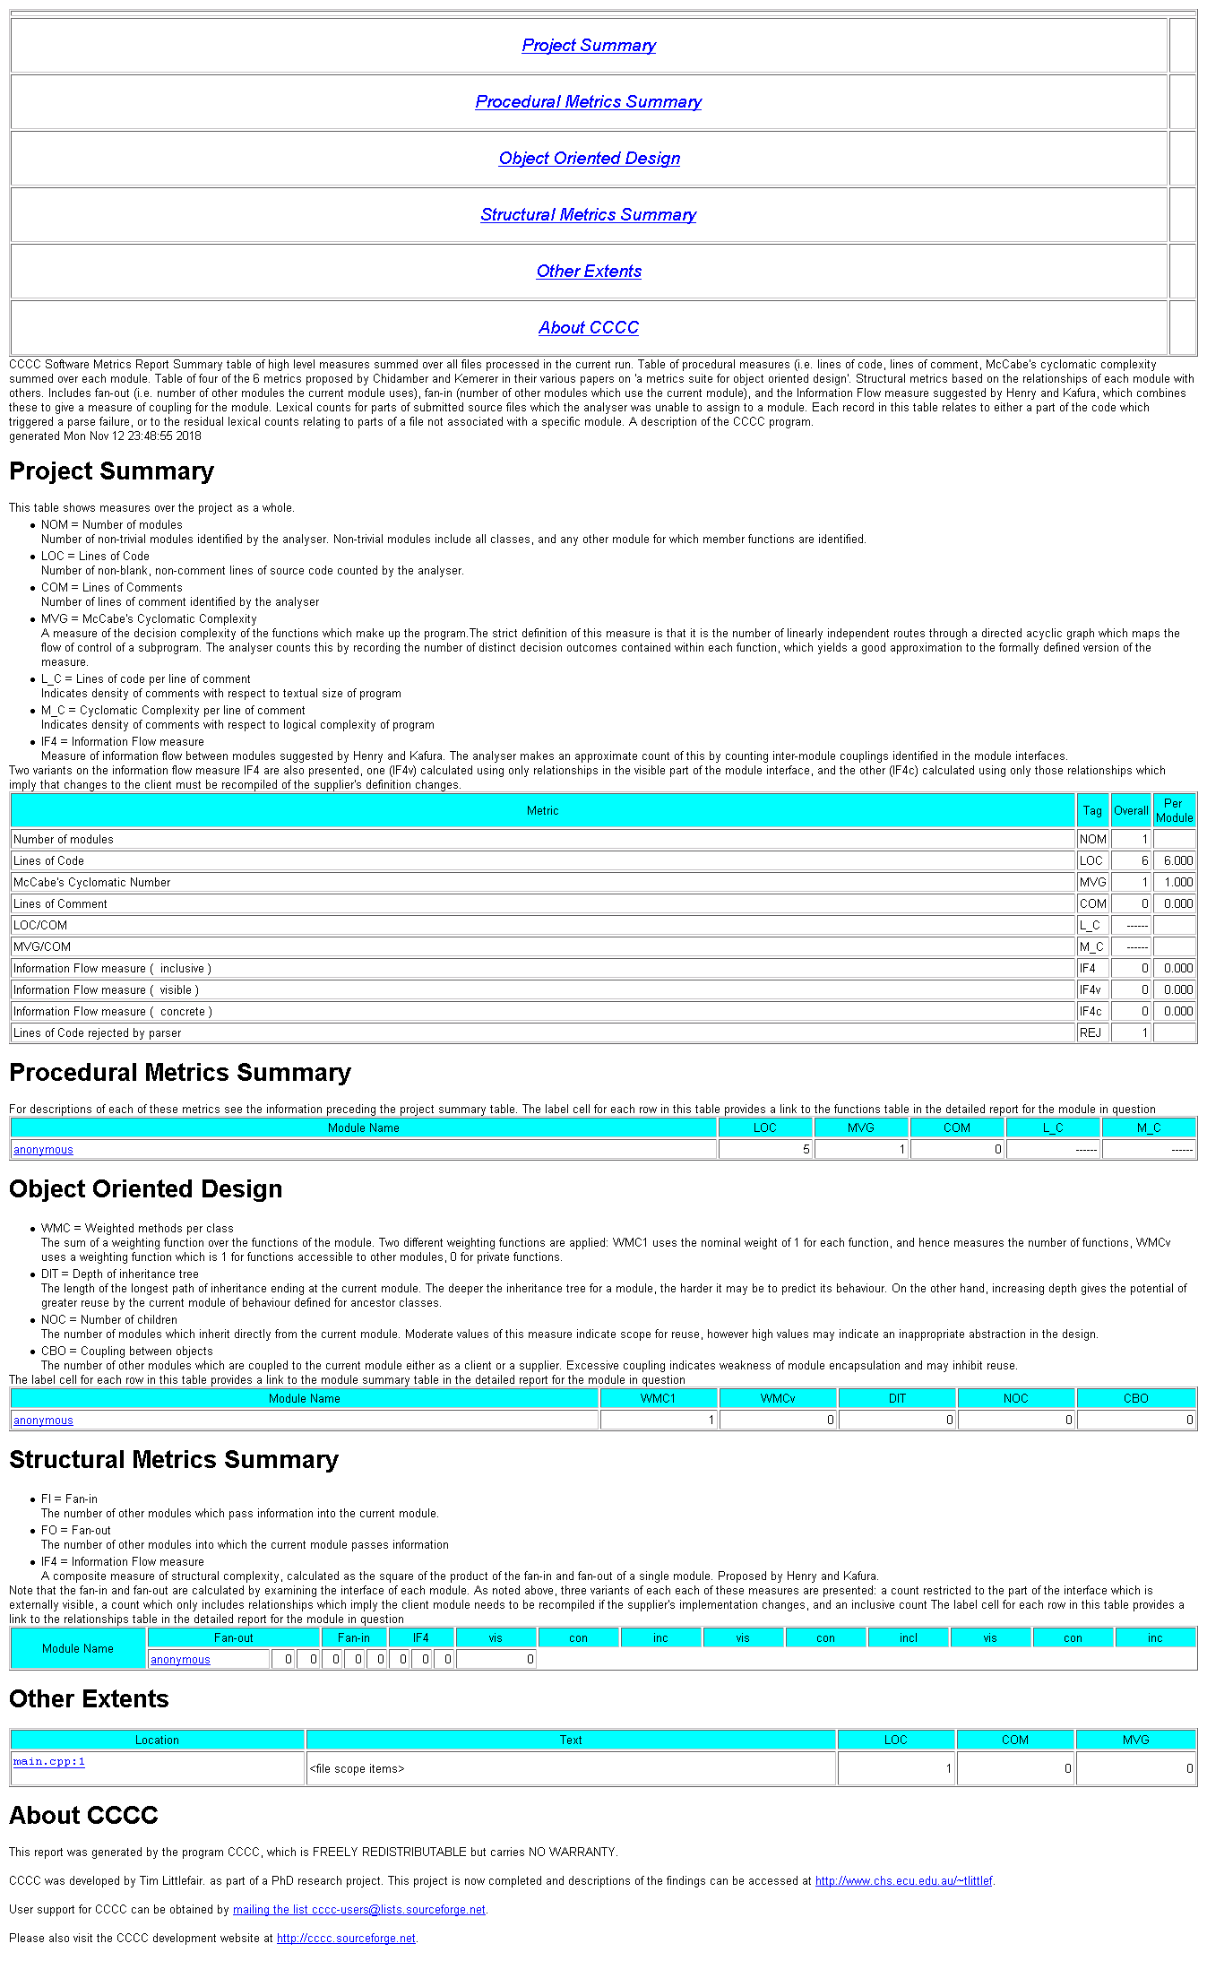

#### 8.0 Minutes of the Meeting with Service Providers

|  |  |
| --- | --- |
| **Minutes of Meeting** | **Date: 10/11/2018**  **Time: 10:30 AM**  **Telephonic Meeting.** |

|  |  |
| --- | --- |
| **Meeting called by:** | Q-Taskers |
| **Meeting for:** | Service Provider |
| **Type of Meeting:** | Telephonic |
| **Name of the shop:** | Jai Durge Electronics |
| **Address:** | E-312, Barra-4, Kanpur, 208027 |
| **Shopkeeper Name:** | Akhilesh Kumar |

|  |  |
| --- | --- |
| **Attendees:** | 1. Karan Inder Singh (U101116FCS057) 2. Rahul Saha (U101116FCS241) 3. Rajat Srivastava (U101116FCS098) 4. Rishabh Gaur (U101116FCS100) 5. Akhlesh Kumar |
|  |  |

***Minutes***

**Agenda items:**

1. To register ‘Jai Durge Electronics’ to the website and fill the ‘join us’ form for them.
2. To discuss with them about the business model and the revenue model of the Q-Taskers.
3. To ask for their valuable opinions or feedback.

**Conclusions:**

Jai Durge Electronics (shop) has been registered as “service provider” for the Q-Taskers, for a tenure of next 6 months.

|  |  |  |
| --- | --- | --- |
| **Action items:** |  |  |
| * Jai Durge Electronics will work for Q-Taskers as “service provider” for a period of next 6 months. * Jai Durge Electronics will repair “lights” and deal with “house wiring system”. * Jai Durge Electronics will work within the 5 Km area of their shop. * Jai Durge Electronics will pay Q-Taskers Rs. 2000 as fee for 6 months. * Every service provided by the Jai Durge Electronics will be verified through a star rating system of the Q-Taskers. * Continuous less than 3-star rating service of Jai Durge Electronics can lead to their rejection of application as “service provider”. * Cost of tools and transportation will be managed by the side of Jai Durge Electronics. * Jai Durge Electronics cannot back-off from providing the services for at-least initial 6 months. * Jai Durge Electronics will have to reach every household within 60 minutes or less or they cannot charge the visiting fee to the customers. * Visiting fee by Jai Durge Electronics cannot exceed Rs. 150. |  |  |
|  |  |  |
|  |  |  |
|  |  |  |